“Supporting everyone’s emotional wellbeing and mental health, so that they can be listened to, are happy together and ready to learn.”

GREEN GATES PRIMARY SCHOOL

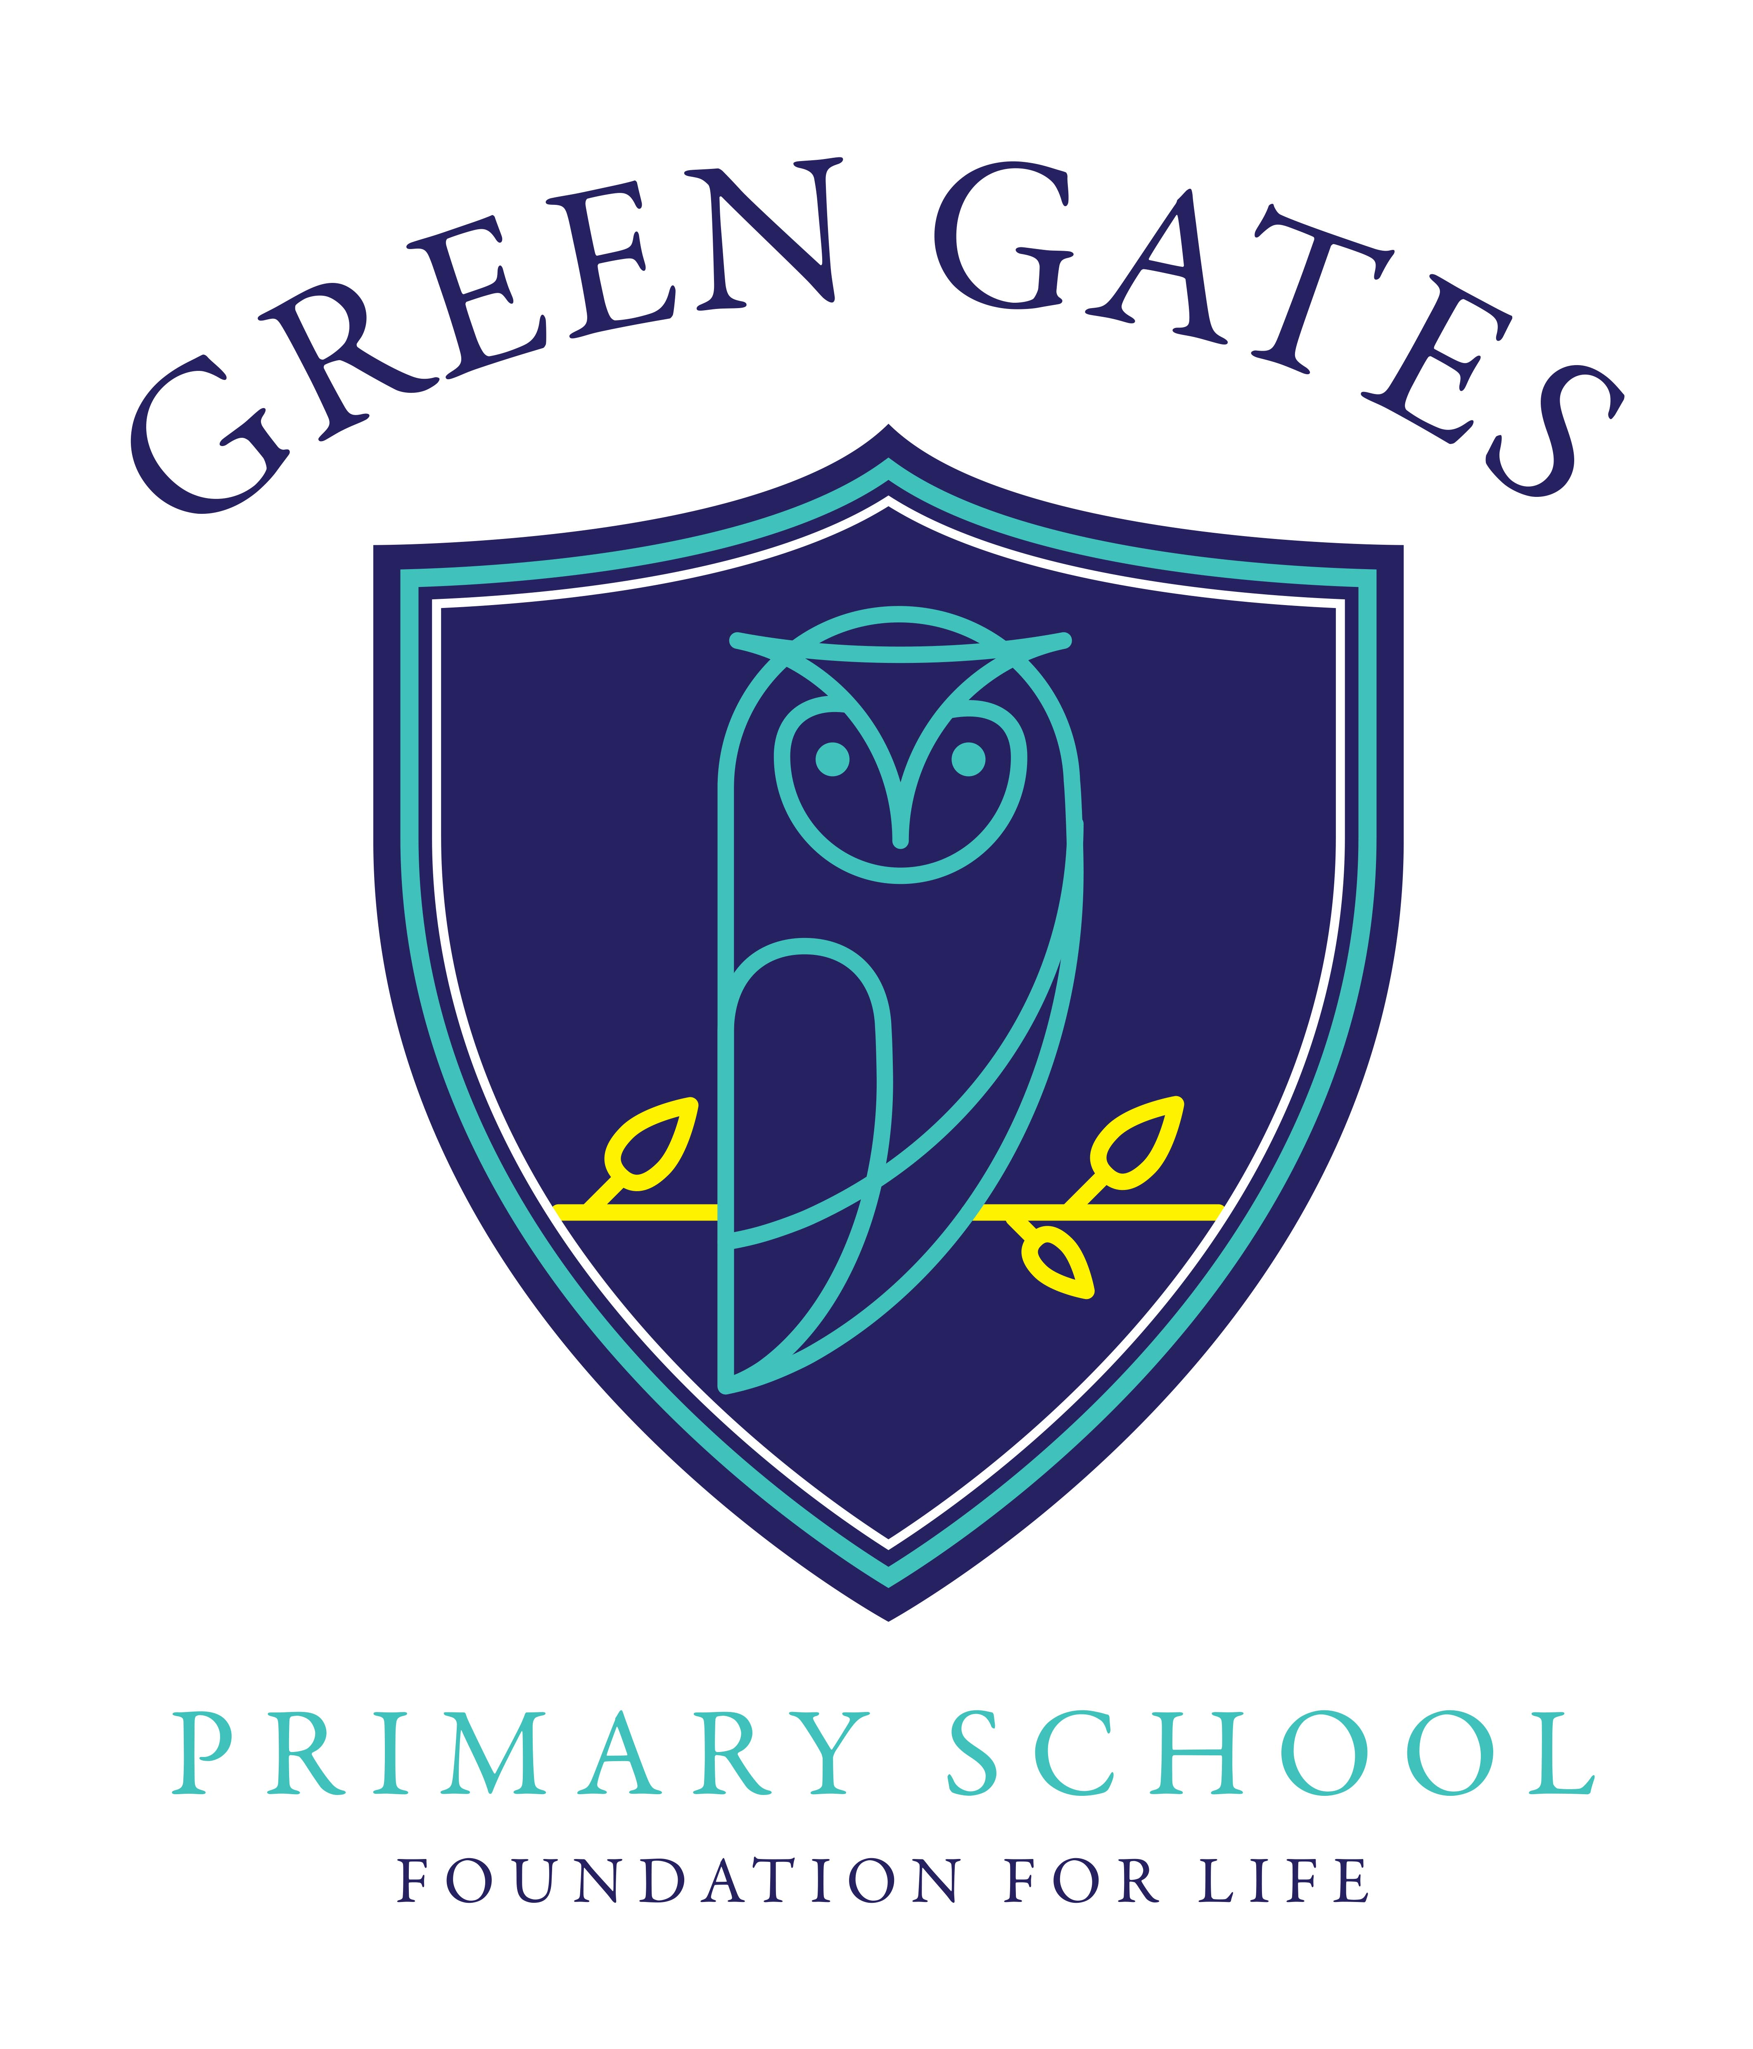

Green Gates Vision and Mission Statement

for

Mental Health & Emotional Wellbeing

It is widely recognised that a child’s emotional health and wellbeing influences their cognitive development and learning, as well as their physical and social health and their mental wellbeing in adulthood. The department for Education recognises that, in order to help their pupils succeed: schools have a role to play in supporting them to be resilient and mentally healthy.
“Mental health is a state of wellbeing in which every individual realises his or her own potential, can cope with the normal stresses of life, can work productively and fruitfully, and is able to make a contribution to her or his community.”
(World Health Organisation 2014)
At Green Gates Primary School, we recognise the importance of emotional wellbeing. We understand that the wellbeing of our children is affected by the wellbeing of the adults they interact with, therefore it is essential that we help protect and promote the emotional health and wellbeing of each and every member of our school community.
We believe that all children are entitled to develop to their fullest potential academically, socially and emotionally, enabling each child to grow in confidence and be able to fully participate in everything that goes on in our school and the wider community with confidence. We recognise that pupils learn at different rates and that there are many factors affecting achievement, including ability and emotional state. We believe that many pupils, at some time in their school career, may experience difficulties which affect their learning. At Green gates, we understand the need for a nurturing, calm and safe environment so children can be ready to learn in a school that provides a positive ethos of promoting good Mental Health and Emotional Wellbeing.

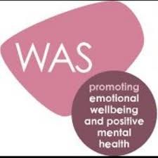
Wellbeing Award for Schools
Our School purpose is “Promote Happiness; Discover Success; Achieve Excellence.” This is the aim of our school vision by “Promising that we will be inclusive, Welcoming, Nurturing, Passionate and Inspiring.” To complement this as part of our commitment to wellbeing of our children, staff and stakeholders, we have begun a journey to work towards achieving a national award called Wellbeing Award for Schools.
It is an award that centres around ensuring effective practice and provision is in place and recognises a school’s efforts to promote and protect positive emotional wellbeing and mental health education and support. The award requires us to recognise what we currently do and offer additional opportunities to support and promote mental health and wellbeing.
The award has a focus on changing the long-term culture of a school and embedding an ethos where mental health is regarded as the responsibility of all. As a school we aim to show commitment to promoting mental health as part of school life, improve the emotional wellbeing of their staff and pupils, ensure mental health problems are identified early and appropriate support provided, offer provision and interventions that matches the needs of its pupils and staff, engage the whole-school community in the importance of mental health awareness and capture the views of parents, pupils and teachers on mental health issues.
At Green Gates Primary School, we care about the wellbeing of our pupils, staff and stakeholders and are always looking for ways that we can help support our wonderful school community.

