Equality Statement

GREEN GATES PRIMARY SCHOOL

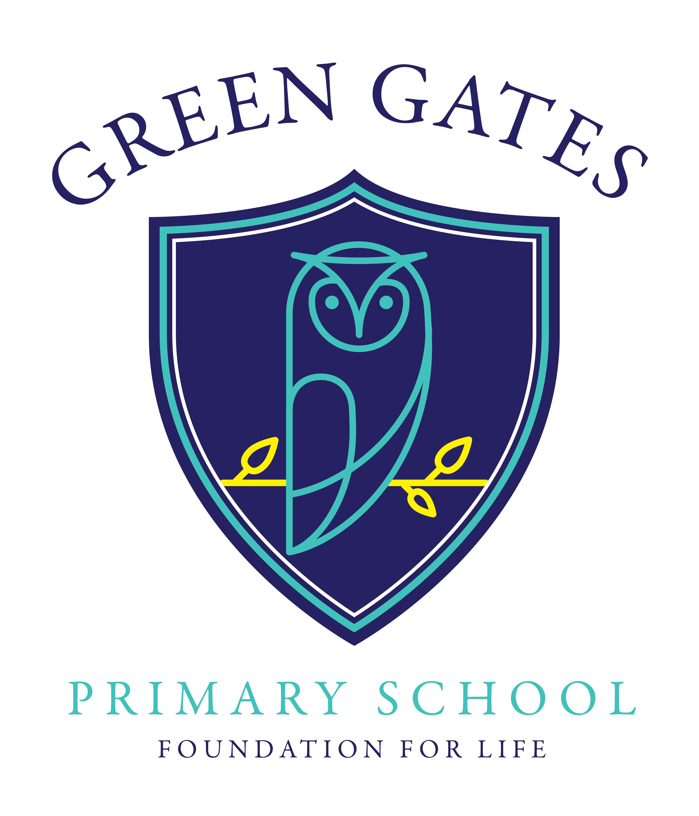

Equality Statement

Revised: February 2020

Review: February 2021
At Green Gates Primary School, we are committed to ensuring equality of opportunity for all pupils, staff, parents and carers irrespective of race, gender, disability, belief, sexual orientation, age or socio-economic background. We are determined to develop a culture of inclusion and diversity in which all those connected to the school feel proud of their identity and ability to participate fully in school life.
We tackle discrimination through the positive promotion of equality, by challenging bullying and stereotypes and by creating an environment which champions respect for all.
We believe that diversity is a strength which should be respected and celebrated by all those who learn, teach and visit us.
Our Equality Objectives are:
1. To ensure that all pupils achieve their full potential
2. To identify barriers to learning and close any gaps in achievement
3. To promote a deep awareness, understanding and appreciation of the diversity of our local, national and global communities.
We shall achieve these objectives by:
1. Maintaining the highest possible expectations of all pupils. We will communicate our ambition by ensuring teaching is consistently of the highest quality, using assessment to inform planning, and rigorously monitoring progress and standards.
2. Identifying vulnerable groups and individuals and developing teaching and learning that is tailored to individual needs, thus ensuring good progress is sustained and achievement gaps can be closed.
3. Identifying every opportunity in the curriculum and in all the activities of the school for deepening the appreciation, understanding and respect we promote for diversity.

