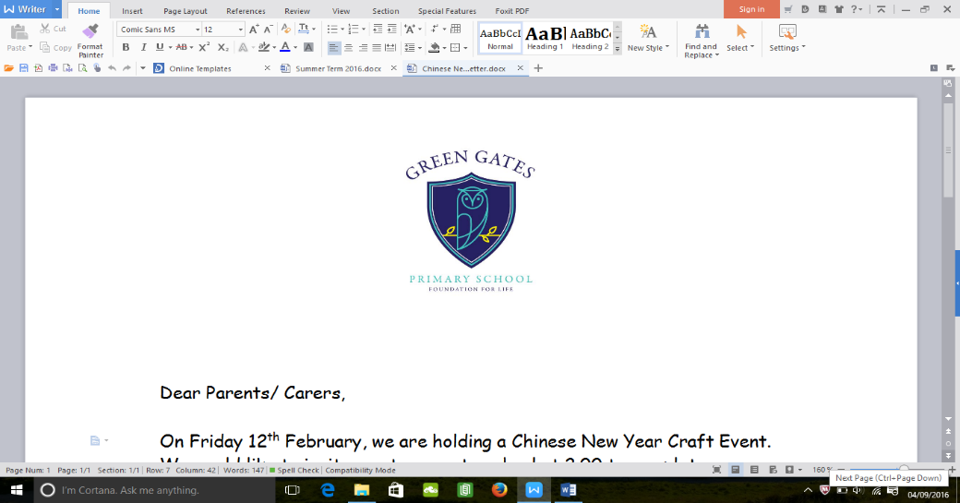

**Our Curriculum**

**Topic -** This term our topic is ‘Stone Age to Iron Age’. The children will be discovering what life was like for our early ancestors! They will be looking at a range of different aspects, including settlements, food and weapons across the time periods.

For a detailed look at what we are going to be covering, please see overleaf.

**English –** Some of our writing this term will be linked to our topic. We will be covering narratives, recounts, instructions and information texts.

**Maths –** This term we will be developing our knowledge of place value, the four operations and measurement.

**Information**

**PE -** Your child will take part in PE lessons every Wednesday. Please ensure they have the correct PE kit in school as soon as possible.

**Reading –** Please encourage your child to read at home daily and support them by filling in their reading journals. This goes towards the children reaching the sun and earning a certificate and a book of their choice!

**Home learning –** Spellings will be sent home on a Monday, and should be returned back to school on the following Friday. Please encourage your children to practise their spellings as they will be tested on these. It is also important for the children to learn their times tables, please support this and practise regularly.

**Our Staff**

Miss Hoggart – Year 3 Teacher

Mrs Depledge – Year 3 Teaching Assistant

If you would like to discuss any matters, please pop in and see me after school or make an appointment for a longer discussion. Thank You, Miss Hoggart.

**Welcome back!**

I hope you have all had a brilliant holiday and are looking forward to the new and exciting challenges ahead!

Year 3 Autumn Newsletter