GREEN GATES PRIMARY SCHOOL

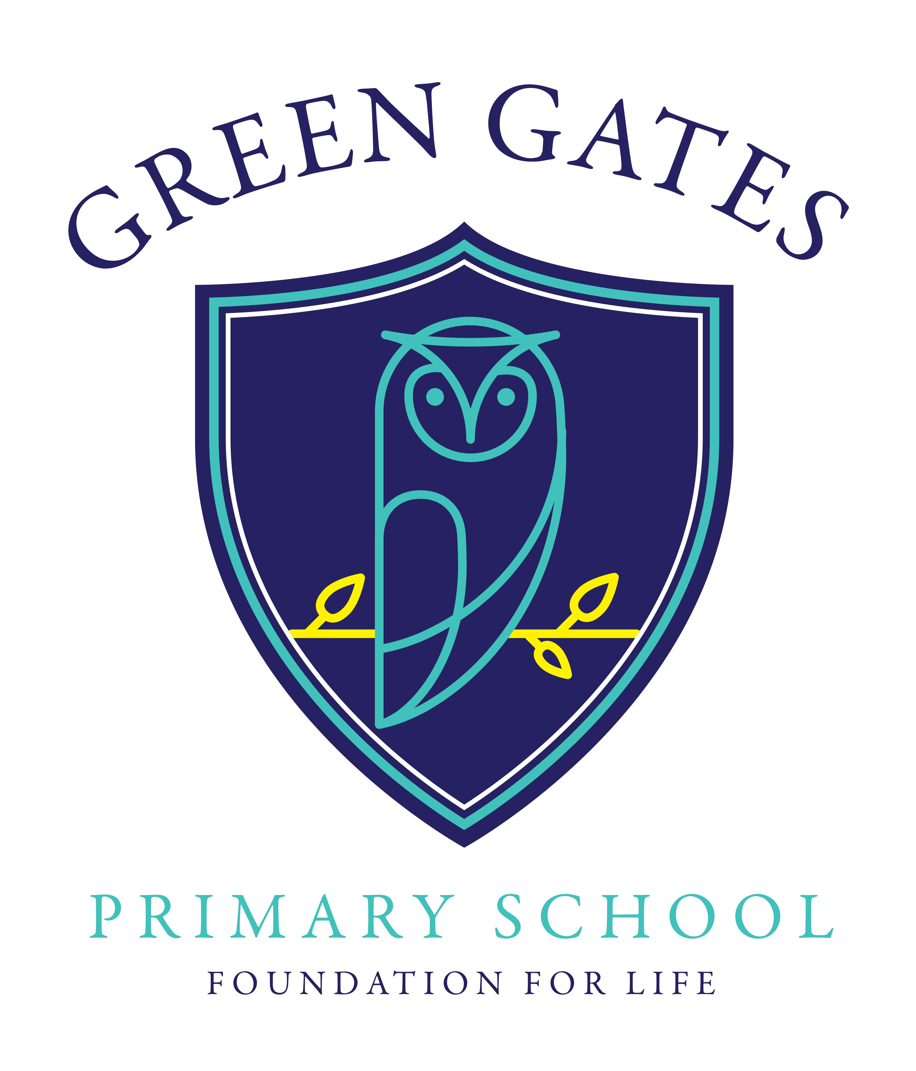

Home Learning Policy

Written: January 2020

Review: January 2022

Green Gates Primary is committed to placing the Convention on the Rights of the Child at the heart of everything we do. We aim to teach children about their rights and help them understand about how rights can differ throughout the world.

Through our home learning opportunities, we believe children have the right to reach their full potential in line with their right to an education sited in Article 28 of the UNCRC (United Nations Convention on the Rights of the Child).

Regular home learning helps children and young people to develop skills and attitudes they will need for successful lifelong learning. Though not compulsory, home learning is a valued part of supporting children through their education and we ask that parents/carers commit to encouraging their child to complete home learning tasks as part of the home/school agreement.

**Effective Home Learning**

* Learning at home is an essential part of good education as it provides all pupils with the opportunity to further their understanding and learning of basic skills in reading, writing and maths;
* To increase pupils’ knowledge, skills and understanding as they grow and develop and strengthen their connections with the world around them;
* To engage the children’s interest by offering opportunities to extend creative learning, challenge their imagination, value originality and to encourage and motivate them to want to learn;
* To develop independent learning habits and encourage children to take responsibility for their own learning.

**Opportunities for Home Learning**

At Green Gates Primary we believe that the focus of home learning should be on the important skills of English and Maths. Our Home Learning comes in the following forms and we ask that you support your child with the following:

* Listen to your child read every day for 10-15 minutes. This will have the greatest impact on your child’s learning within school;
* Support your child to learn their weekly spellings;
* Support your child to learn the times tables they have been given to learn;

In addition to this, we also provide the following:

* An optional menu based project which is linked to the wider curriculum. This is to encourage family time;
* Additional English or Maths tasks may be given if your child is struggling with a specific concept within school.

**Available Resources**

The following are examples of support and where to find ideas to support home learning:

* + Curriculum newsletters – termly;
  + School website – has links to interactive sites;
  + Free interactive website, such as BBC Bitesize;

Support is also available through workshops that school is able to offer eg phonics, reading, mathematics, E-Safety.

If you require any further support with Home Learning, please do not hesitate to contact the school.