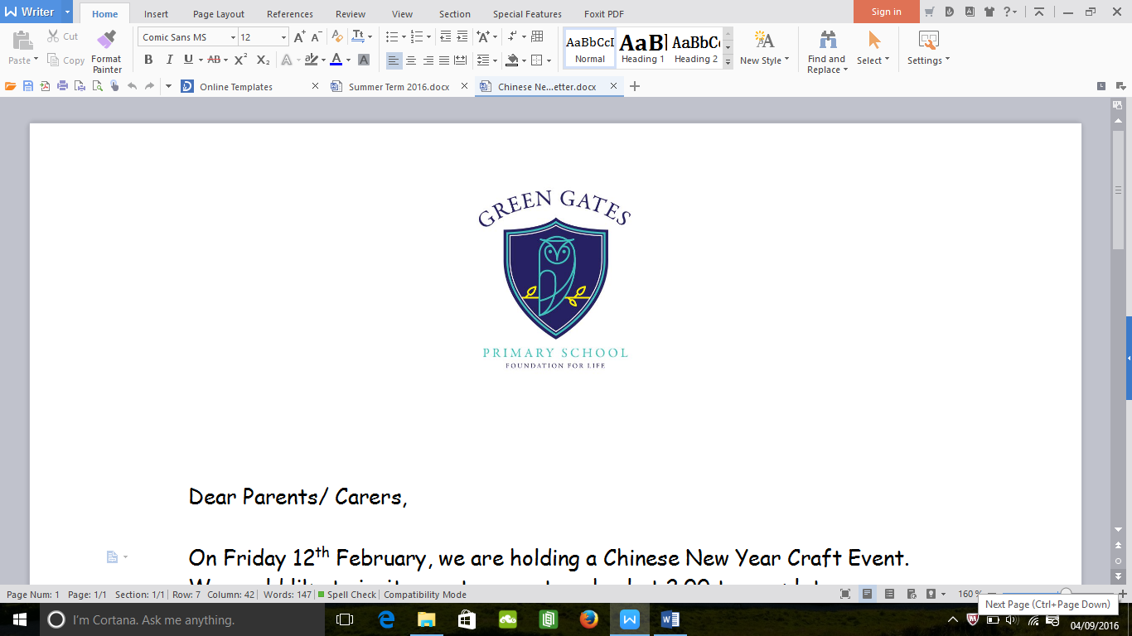

**What do we do?**

We keep the students and parents informed of all the activities and fundraising opportunities coming up throughout the school year. We actively encourage links with our community by inviting different adults into school to give assemblies or lessons. We meet regularly to discuss improvements and new ideas to make the school better.

**Head Boy and Head Girl**

Our Head Boy and Head Girl have very important roles within school. They help organise events and give out a special award every Friday in assembly, linked to our rights.

**Meet your Ambassadors**

Head Boy and Head Girl

Kaden and Abigail

Ellie and Laila in Year 6.

Leon and Madison in Year 5.

Kaiden in Year 4.

Laila in Year 3.

Macie and Heidi in Year 2.

Lily in Year 1.

Pupil Voice Newsletter

School Ambassadors

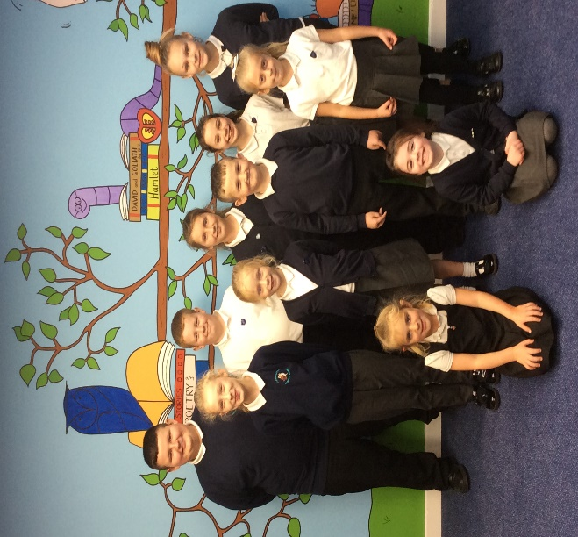



**Nursery Team**

Miss Parker- Nursery Teacher

Mrs Robertson- Teaching Assistant

Miss Barlow- Teaching Assistant

Please do not hesitate to speak to us if you have any questions or queries.