School Ambassadors

How can we help make the school even better?

What needs to get better? | How can our children help?
Quality of Education  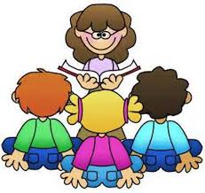  - Curriculum experiences – more trips / visits / exciting lessons  - Knowledge organisers  - Get better at basic skills  - “Outstanding” teaching | 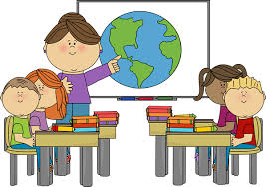  - Engage well with their lessons – are they listening? Answering questions? Asking questions?  - Make an effort to learn the information on their knowledge organisers  - Learn your spellings each week and your times tables  - Take pride in your work – make your books beautiful!
Behaviour and Attitudes  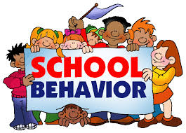  - Achieve the Gold award for Rights Respecting Schools  - Develop a love of reading | - Learn your rights – talk about them  - Be really good role models  - Make sure you show respect for all adults at all times  - Remember your wonderful manners  - Help us create some magical reading spaces around school – give us ideas  - Speak to your teachers about books and stories you like
Personal Development  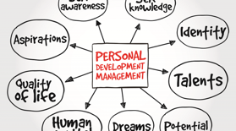  - Develop Mental Health and Wellbeing | - Look after yourselves!  - If you need to speak to someone or are feeling unhappy or sad, please speak to an adult in school  - Participate in PE lessons – bring your PE kit  - Take an active part in Jigsaw lessons and assemblies  - Help improve school meals even further
Leadership and Management  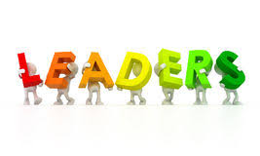  - Subjects to be led well  - Involve parents more | - Know which subject you are doing  - Talk to subject leaders about what you have learnt  - Try to remember the key knowledge you have been taught  - Encourage your parents to come to all school events – Fairs, End of topic celebrations, lesson sharing etc

