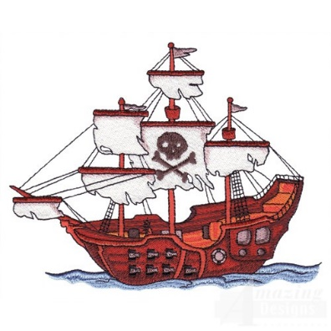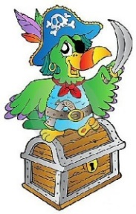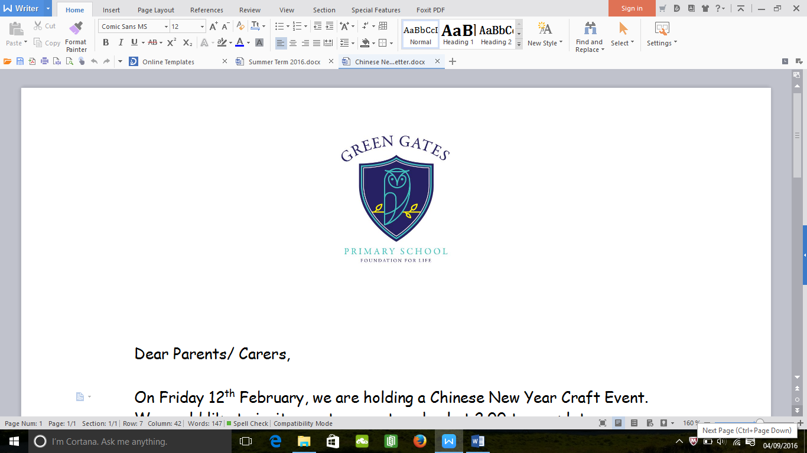

**What will your child be learning?**

Next term our topic is **‘Ship Ahoy’.** We will start the topic looking at the story ‘The Night Pirates’ and we have visits from a pirate and a pirate day planned. The children will then read ‘Pirates love Underpants’ and design Following this, we will read the book ‘The Pirates Next Door’. Your child will have a pen pal in school to write to and will design and make their own treasure chest.

In addition to this, your child will be taking part in daily maths focusing on counting skills, recognising numbers, addition and subtractions. In addition, they take part in and RWI sessions which focus on recognising sounds, reading and writing words and sentences. We will be focusing on the children sounding out and writing words independently this term so please encourage your child at home.

We will have a story of the week which will be displayed in the entrance area. Please support your child’s development by using the vocabulary and talking to them about the books we are reading at home.

**Information**

Your child will be taking part in PE lessons every Tuesday and will require a PE kit in school. Please check your child’s kit to ensure it has their name written inside.

We also ask for a voluntary 30p contribution towards the Foundation Stage Fund each week which goes towards baking activities and messy play resources for your child.

Welcome Back

We hope you have had a lovely Easter. Our chicks have now gone back to the farm and we are excited to begin our new topic.

Reception Newsletter

Summer Term 2019

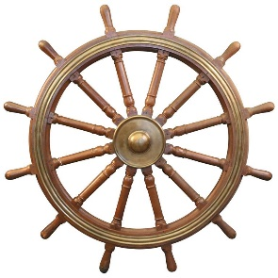 

**Reception Team**

Mrs Fellows- Reception Teacher

Mrs Byrne- Teaching Assistant

Please do not hesitate to speak to us if you have any questions or queries.

You can help your child’s learning in this topic by using the following **vocabulary** at home and helping them to learn what each word means.

|  |  |
| --- | --- |
| **Porthole** | a [small](https://www.macmillandictionary.com/us/dictionary/american/small_1) [window](https://www.macmillandictionary.com/us/dictionary/american/window) in the side of a [ship](https://www.macmillandictionary.com/us/dictionary/american/ship_1). |
| **Compass** | A tool to help you with directions. |
| **Spy Glass** | A small telescope used by sailors. |
| **Navigate** | To find the way to get to a place when you are traveling in a ship. |
| **Cabin** | A [private](https://www.macmillandictionary.com/us/dictionary/american/private_1) [room](https://www.macmillandictionary.com/us/dictionary/american/room_1) on a [ship](https://www.macmillandictionary.com/us/dictionary/american/ship_1) for a [passenger](https://www.macmillandictionary.com/us/dictionary/american/passenger) or one of the [people](https://www.macmillandictionary.com/us/dictionary/american/people_1) [working](https://www.macmillandictionary.com/us/dictionary/american/working) on the [ship](https://www.macmillandictionary.com/us/dictionary/american/ship_1). |
| **Deck** | One of the levels on a ship, train, or stadium. |
| **Helm** | A [wheel](https://www.macmillandictionary.com/us/dictionary/american/wheel_1) or [handle](https://www.macmillandictionary.com/us/dictionary/american/handle_1) [used](https://www.macmillandictionary.com/us/dictionary/american/used) for [making](https://www.macmillandictionary.com/us/dictionary/american/making) a [boat](https://www.macmillandictionary.com/us/dictionary/american/boat) go in the [direction](https://www.macmillandictionary.com/us/dictionary/american/direction) you [want](https://www.macmillandictionary.com/us/dictionary/american/want_1). |
| **Bridge** | The part of a [ship](https://www.macmillandictionary.com/us/dictionary/american/ship_1) from which it is [controlled](https://www.macmillandictionary.com/us/dictionary/american/controlled_1). |

**Help at home by:**

* Reading daily with your child, this is extremely important in order to help your child build up their knowledge of vocabulary and stories.
* Practising the set 2 and 3 sounds at home and reading and writing these in words.
* Writing simple sentences using finger spaces that end with a full stop.
* Adding and subtracting two one digit numbers. E.g. there are 5 plates on the table, we need two more, how many will there be altogether?
* Take your child to the park/ farm/ beach and talk about the changing seasons.
* Encouraging your child to try new and different foods.