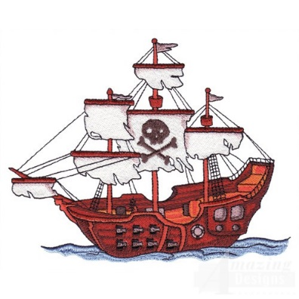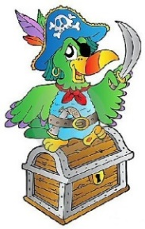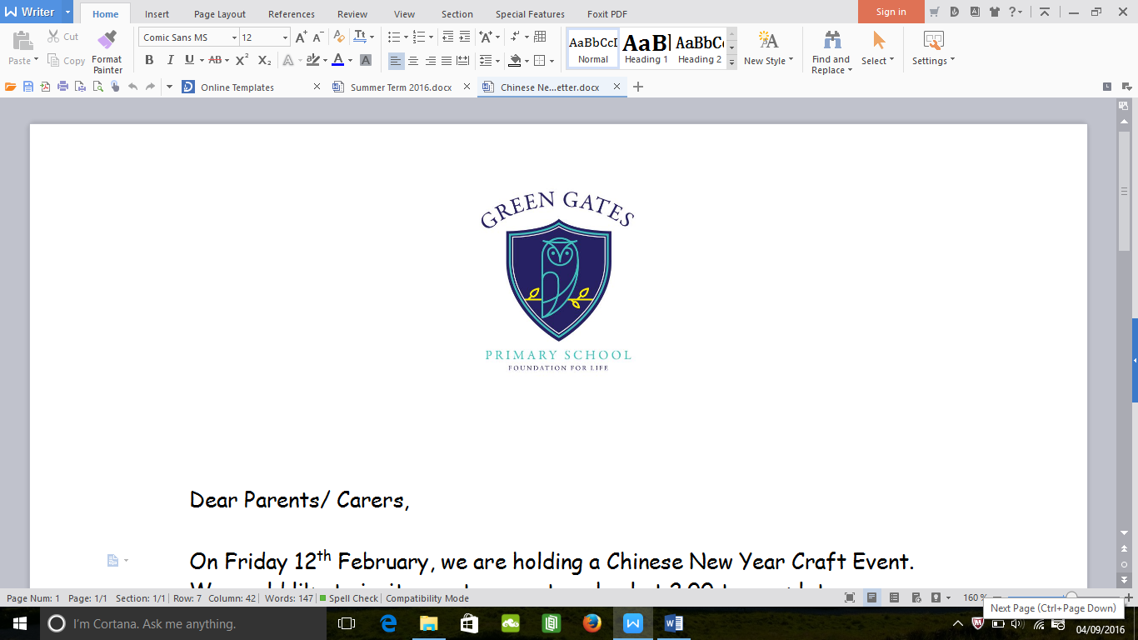

**What will your child be learning?**

Next term our topic is **‘Ship Ahoy’.** We will start the topic looking at the story ‘The Night Pirates’ and we have a pirate themed day planned with visits from pirates! The children will then read ‘Pirates love Underpants’ and design a pair of underpants. Following this, we will read the book ‘The Pirates Next Door’ and your child will design and make their own treasure chest.

In addition to this, your child will be taking part in maths sessions focusing on counting skills and recognising numbers and shapes. They will also take part in phonics sessions which focus on recognising sounds and writing sounds. We will be focusing on recognising sounds independently this term so please encourage your child at home.

We will have a story of the week which will be displayed in the entrance area. Please support your child’s development by using the vocabulary and talking to them about the books we are reading at home.

**Information**

Your child will be taking part in PE lessons every other Wednesday and will require a PE kit in school. Please check your child’s kit to ensure it has their name written inside.

We also ask for a voluntary 30p contribution towards the Foundation Stage Fund each week which goes towards baking activities and messy play resources for your child.

Welcome Back

We hope you have a lovely Easter. Our chicks are going to the farm over Easter and we are excited to begin our new topic in Summer term.

Nursery Newsletter

Summer Term 2019

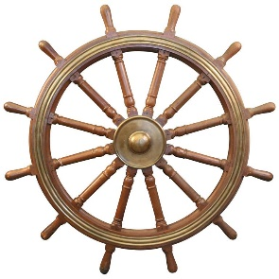 

**Reception Team**

Miss Parker- Nursery Teacher

Mrs Robertson- Teaching Assistant

Please do not hesitate to speak to us if you have any questions or queries.

You can help your child’s learning in this topic by using the following **vocabulary** at home and helping them to learn what each word means.

|  |  |
| --- | --- |
| **Porthole** | a [small](https://www.macmillandictionary.com/us/dictionary/american/small_1) [window](https://www.macmillandictionary.com/us/dictionary/american/window) in the side of a [ship](https://www.macmillandictionary.com/us/dictionary/american/ship_1). |
| **Compass** | A tool to help you with directions. |
| **Spy Glass** | A small telescope used by sailors. |
| **Navigate** | To find the way to get to a place when you are traveling in a ship. |
| **Cabin** | A [private](https://www.macmillandictionary.com/us/dictionary/american/private_1) [room](https://www.macmillandictionary.com/us/dictionary/american/room_1) on a [ship](https://www.macmillandictionary.com/us/dictionary/american/ship_1) for a [passenger](https://www.macmillandictionary.com/us/dictionary/american/passenger) or one of the [people](https://www.macmillandictionary.com/us/dictionary/american/people_1) [working](https://www.macmillandictionary.com/us/dictionary/american/working) on the [ship](https://www.macmillandictionary.com/us/dictionary/american/ship_1). |
| **Deck** | One of the levels on a ship, train, or stadium. |
| **Helm** | A [wheel](https://www.macmillandictionary.com/us/dictionary/american/wheel_1) or [handle](https://www.macmillandictionary.com/us/dictionary/american/handle_1) [used](https://www.macmillandictionary.com/us/dictionary/american/used) for [making](https://www.macmillandictionary.com/us/dictionary/american/making) a [boat](https://www.macmillandictionary.com/us/dictionary/american/boat) go in the [direction](https://www.macmillandictionary.com/us/dictionary/american/direction) you [want](https://www.macmillandictionary.com/us/dictionary/american/want_1). |
| **Bridge** | The part of a [ship](https://www.macmillandictionary.com/us/dictionary/american/ship_1) from which it is [controlled](https://www.macmillandictionary.com/us/dictionary/american/controlled_1). |

**Help at home by:**

* Reading daily to your child, this is extremely important in order to help your child build up their knowledge of vocabulary and stories.
* Reading familiar signs and labels at home or in the shops. E.g. Tesco, ASDA.
* Practising set 1 sounds at home.
* Singing songs and nursery rhymes.
* Counting. E.g. the number of plates on the table, the number of stairs on the way to bed.
* Take your child to the park/ farm/ beach and talk about new life and any signs of Summer.
* Encouraging your child to become more independent in dressing themselves.