­­­­­­ 

**Autumn 2 Newsletter**

Dear Parents / Carers,



A few dates for diaries…

Monday 7th January – Return to school

Monday 7th January – To launch our Rights Respecting School Award, we will be holding a rights week in school. There are lots of fun things planned.

Monday 4th February – Year 6 Residential trip

Tuesday 5th February – E safety workshops for Years 2-5



**It’s been a busy half term in the run up to Christmas with lots of exciting learning going on right across school…**

Inter-Faith week

In November, we took part in inter-faith week where each year group learnt all about different religions. EYFS looked at Christianity and went to the church for a beautiful wedding. Year 1 and 2 children learnt all about Buddhism and created their very own Mandalas. Year 3 and 4 visited the Hindu temple whilst Year 5 and 6 had a fantastic visit from the Islamic Diversity Centre.

Topics

Our Autumn term topics ended with some fabulous showcase events. Thank you to all parents who were able to attend – the children love having you come into school to show off their work.

Christmas

The school have enjoyed a visit to the Pantomime, as well as a trip to Church for a Christingle Service. Performances are happening this week – enjoy!



The children have developed our new school values. At Green Gates, our children are…

Happy, Respectful, Resilient, Friendly and Honest.

We have these values displayed around school. The children were responsible for the design of these and we think they look incredible.



Remember to follow us on Twitter @GreenGatesPri for lots of updates from each class. We share lots of pictures of our wonderful learning for you all to see.



**Links with the Community**

This half term, we have been working hard to create links with the local and wider community.

Christmas Jumper Day – A HUGE Thank You, once again. We raised £160 for Save the Children UK.

Redcar Food Bank – We now have a permanent collection point in the entrance. Thank you to everyone for your kind donations so far.

Choir – Our gorgeous choir, alongside our dedicated staff, have been to spread Christmas cheer at various venues including Kirkleatham Almshouses, Tesco, Roseberry Square and The Dunes.

Yew Tree – Some of our lovely reception children have been to take part in craft activities and share stories with the residents of Yew Tree. This will continue into the new year.

Show Racism the Red Card – Year 5 and 6 learnt all about Racism with an interactive, fun-filled day.

If you can think of any events or organisations we should be getting involved in, please let us know.

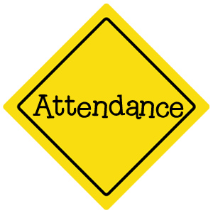Please make sure that you get your children into school and on time. At the moment, we are having lots of absences from the school, as well as a significant amount of children turning up after 8.55am. Every minute counts and we don’t want any child missing out on the wonderful learning taking place. Thank you for your support with this.

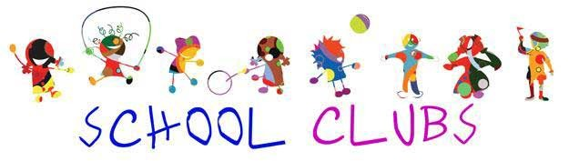

I think you will agree that this term we have had an abundance of after school clubs on offer! Lots of these will continue into the New Year and there will even be some new ones. Look out for the letters.

As always, if you have any questions, queries or concerns, please do come and see me. My door is always open.

Thank you for all of your support so far this year, Mrs Lowe. ☺