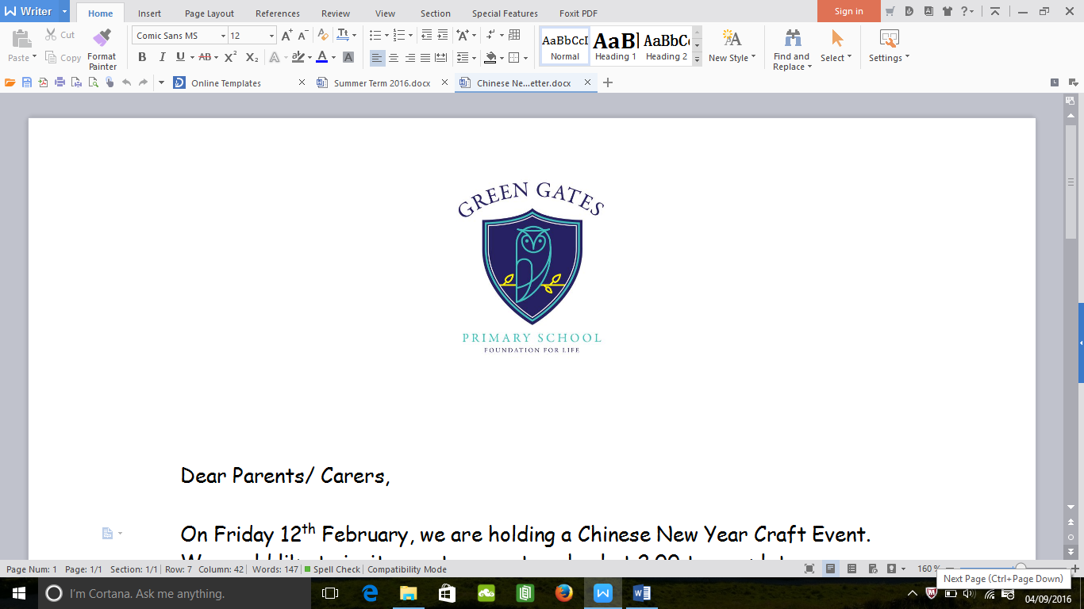

**You can help at home by:**

* Reading daily with your child.
* Recognising letters and numbers on car number plates, signs etc.
* Singing songs and nursery rhymes.
* Counting- e.g. the number of plates on the table, the number of stairs on the way to bed.
* Practising your child’s keywords with them.
* Reading lots of different traditional tales with your child and talking about the characters etc.
* Taking your child to the beach, woods, shops etc

**What will your child be learning?**

This term our topic is ‘**Once Upon a Time**. We will be reading lots of traditional tales and creating our own alternative stories. Your child will also be taking part in daily read, write, inc sessions to help them learn to read. Through our topic, we will be talking about what is right and wrong, learning about how stories are structured and learning more about the characters and animals in the stories. Over the half term, we will be focusing on different stories including:

* Goldilocks and the three bears
* Three Billy Goats Gruff
* The Little Red Hen

**Reception Team**

Mrs Fellows- Reception Teacher

Mrs Byrne- Teaching Assistant

Mrs Robertson- Teaching Assistant

Please do not hesitate to speak to us if you have any questions or queries.

**Information**

Your child will take part in a PE lessons every week. Please ensure your child has their PE kit in school as soon as possible.

Your child has a book bag which contains a reading book and keywords, please read with your child as often as you can and ensure they bring their school bag each day.

In Reception we continue to ask for a 30p donation towards the Foundation Stage Fund and we aim to cook with your child each week.

**Welcome**

Welcome back! We hope you have had a lovely summer holiday. We are looking forward to working with you and your child over the next year and helping them to develop and grow.

Reception Newsletter

Autumn Term 2018