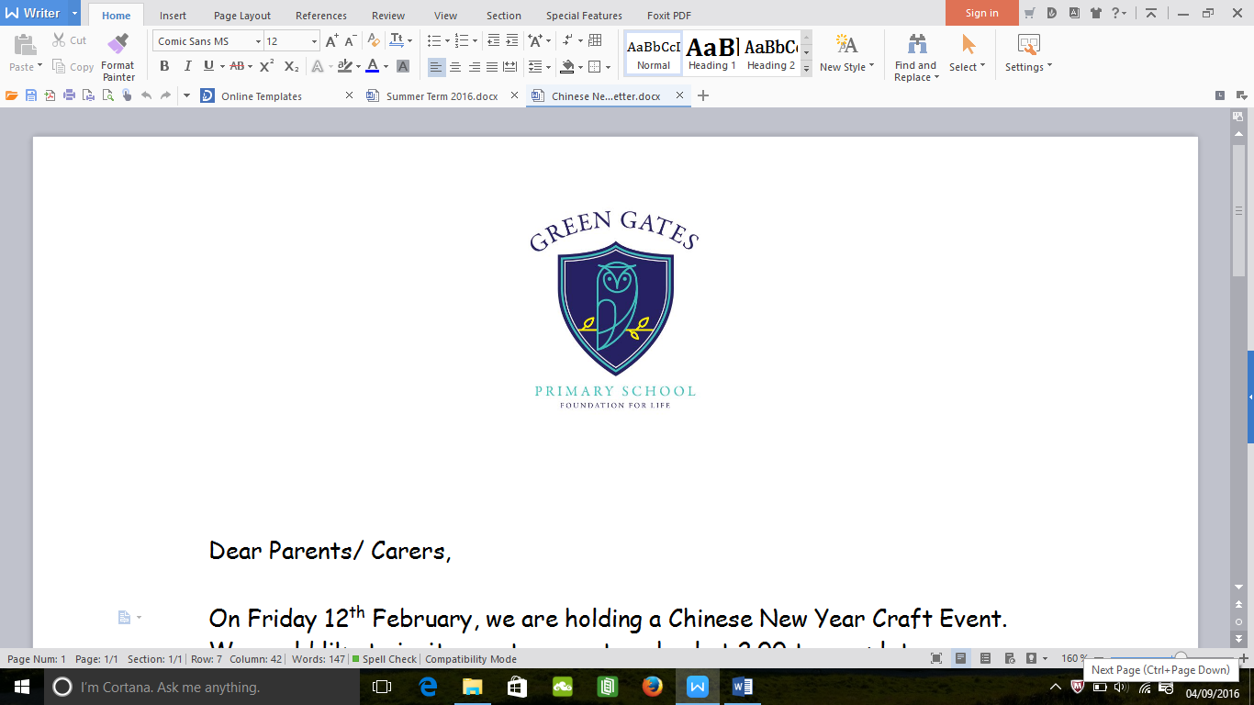

**Information**

Your child will be taking part in PE lessons every Wednesday morning and we will also be starting Yoga Bugs sessions every Thursday morning. Children will need to take their shoes and socks off for both sessions.

Please can children also bring a **30p** contribution towards the Foundation Stage Fund **each week**? This money goes towards baking activities and messy play resources for your child.

**You can help at home by:**

* Reading daily with your child. This is extremely important in order to help your child progress with their reading in school.
* Reading signs and labels at home or in the shops.
* Singing songs and nursery rhymes.
* Counting- e.g. the number of plates on the table, the number of stairs on the way to bed. Can your child tell you one more or one less than that number?
* Take your child to the park/ farm/ beach and talk about new life and any signs of spring.

**What will your child be learning?**

This term our topic is ‘**Once upon a time’**. We will be looking closely at Goldilocks and The Three Bears, The Three Billy Goats Gruff and The Little Red Hen. The children will be recreating the stories through role play and creating artwork linked to each story. We are also planning a visit to a local park as part of our new topic.

Your child will be taking part in daily maths and phonics sessions focusing on counting skills, recognising numbers and sounds and talking about their thoughts and feelings.

We will have a sound and number of the week which will be displayed in the entrance area. Please support your child’s development by reinforcing these at home and encouraging your child to use them.

**Nursery Team**

Miss Parker- Nursery Teacher

Mrs Dowson- Teaching Assistant

Mrs Thompson- Teaching Assistant

Please do not hesitate to speak to us if you have any questions or queries.

**Welcome**

Welcome back! I hope that you have enjoyed your summer holidays and that the children are feeling refreshed. I am looking forward to working in Nursery this year.

Nursery Newsletter

Autumn Term 2018