Every child deserves the best possible start in life and the support that enables them to fulfil their potential. Children develop quickly in the early years and a child’s experiences between birth and age five have a major impact on their future life chances. A secure, safe and happy childhood is important in its own right. Good parenting and high quality early learning provide the foundation children need to make the most of their abilities and talents as they grow up. (Statutory Framework for Early Years Foundation Stage 2017)

GREEN GATES PRIMARY SCHOOL

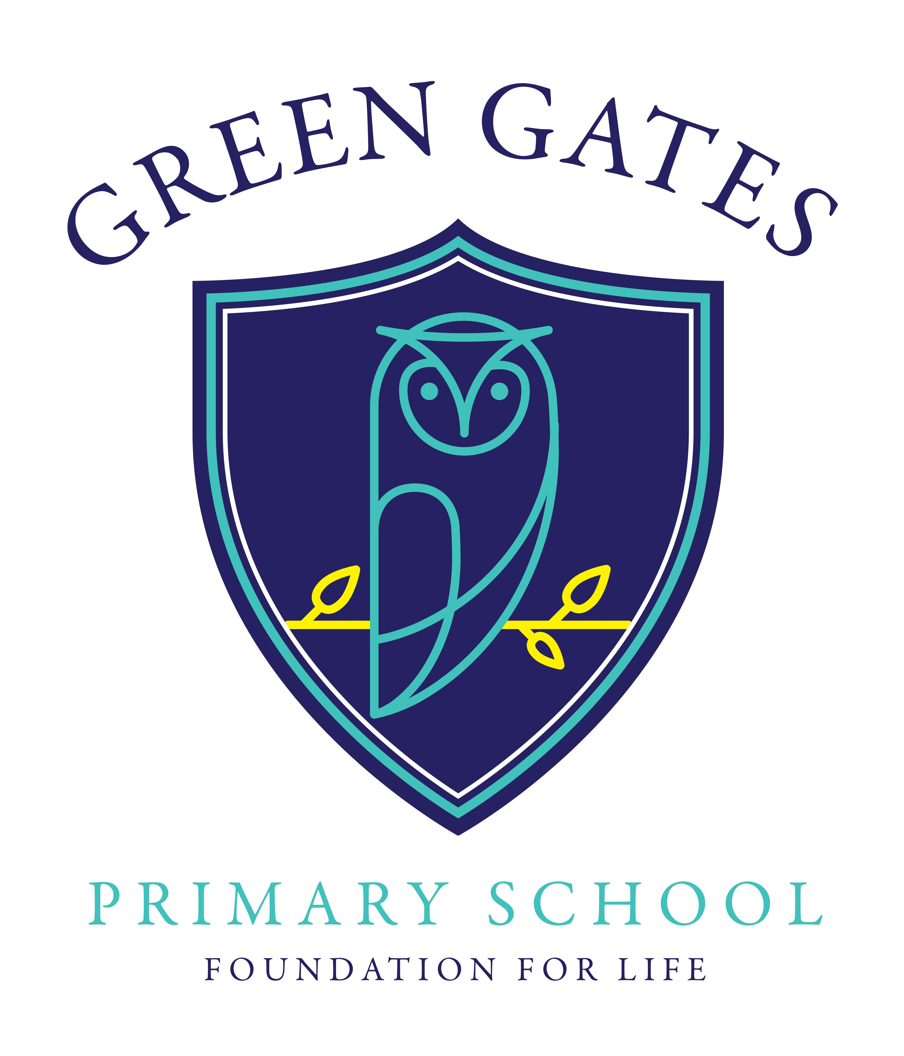

Early Years Policy

Written: June 2018

Review: June 2020
The Early Years Foundation Stage (EYFS) applies to children from birth to the end of the reception year. In our school, most children join us, part time, after their third birthday. They move from Nursery to Reception in the September after their fourth birthday.
The EYFS principles which guide the work of all practitioners are grouped into four distinct but complementary themes:
- A Unique Child
- Positive Relationships
- Enabling Environments
- Learning and Development

Effective practice in the EYFS is built on these four guiding themes. They provide a context for the requirements and describe how practitioners should support the development, learning and care of young children. This policy outlines how we meet each of the four themes.

A Unique Child
At Green Gates Primary School we recognise that every child is a competent learner from birth who can be resilient, capable, confident and self-assured. We recognise that children develop in individual ways, at varying rates. Children’s attitudes and dispositions to learning are influenced by feedback from practitioners; we use praise and encouragement, as well as celebration assemblies and rewards, to encourage children to develop a positive attitude to learning. Nursery children earn stickers and rewards. Reception children earn smiley faces from the time they start Green Gates and are encouraged to earn 100 smiley faces a term.

Inclusion
At Green Gates Primary School we value the diversity of individuals within the school and do not discriminate against children because of differences. All children are treated fairly regardless of race, religion or abilities. All children and their families are valued within our school.
We give children every opportunity to achieve their best. We do this by taking account of our children’s range of life experiences when planning for their learning.
In EYFS we set realistic and challenging expectations that meet the needs of our children. We achieve this by planning to meet the needs of boys and girls, children with special educational needs, children who are more able, children with disabilities, children from all social and cultural backgrounds, children of different ethnic groups and those from diverse linguistic backgrounds.
We meet the needs of all our children through:
- planning opportunities that build upon and extend children’s knowledge, experience and interests, and develop their self-esteem and confidence;
- using a wide range of teaching strategies based on children’s learning needs;
- providing a wide range of opportunities to motivate and support children and to help them to learn effectively;
- working in small groups to ensure all children can access learning.
- providing a safe and supportive learning environment in which the contribution of all children is valued;
- using resources which reflect diversity and are free from discrimination and stereotyping;
- planning challenging activities for children whose ability and understanding are in advance of their language and communication skills;
- monitoring children’s progress and taking action to provide support as necessary.
- using meetings with parents to set realistic targets.
- providing opportunities to explore different cultures, customs and lifestyles.
- assigning each child a key person in nursery to ensure every child’s individual needs are catered for.
- Ensuring that EYPP funding is utilised so that it has a positive impact on attainment and closes the gap for each eligible child.

Welfare
It is important to us that all children in the school are safe. We aim to educate children on boundaries, rules and limits and to help them understand why they exist. We provide children with choices to help them develop this important life skill. Children should be allowed to take risks, but need to be taught how to recognise and avoid hazards.
We aim to protect the physical and psychological well-being of all children. (See Child Protection Policy)
“Children learn best when they are healthy, safe and secure, when their individual needs are met, and when they have positive relationships with the adults caring for them.” Statutory Framework for Early Years Foundation Stage 2017

We understand that we are legally required to comply with welfare requirements as stated in the Statutory Framework for Early Years Foundation Stage 2017. We understand we are required to:
- promote the welfare of children.
- promote good health, good hygiene and taking appropriate action when children are ill.
- manage behaviour effectively in a manner appropriate for the children’s stage of development and individual needs.
- ensure staffing arrangements are organised to ensure safety and to meet the needs of the children.
- ensure all adults who look after the children or who have unsupervised access to them are suitable to do so.
- ensure visitors and parent helpers wear appropriate ID badges.
- ensure outdoor and indoor spaces, furniture, equipment and toys, are safe and suitable for their purpose.
- ensure that every child receives enjoyable and challenging learning and development experiences tailored to meet their needs.
- maintain records, policies and procedures required for safe efficient management of the setting and to meet the needs of the children.

We endeavour to meet all these requirements through:
- using the school’s Child Protection Policy;
- having named staff/governors who are responsible for safeguarding
- having secure premises;
- using the school’s SEND policy;
- ensuring all staff who work within the EYFS have received paediatric first aid training;
- providing children with fresh drinking water and a healthy snack;
- ensuring our premises are smoke free;
- using the school’s behaviour policy;
- having any one who works directly with children CRB checked;
- following the staff to child ratios set out in the statutory framework;
- carrying out a risk assessment each year and whenever necessary;
- planning to meet children’s needs;
- keeping up to date records of children in our setting
- following the school’s Educational Visits Policy

Positive Relationships
At Green Gates Primary School we recognise that children learn to be strong, confident and independent from being in secure relationships. We aim to develop caring, respectful, professional relationships with the children and their families.

Parents as Partners
We recognise that parents/carers are children’s first and most enduring educators and we value the contribution they make. We recognise the role that parents/carers have played, and their future role, in educating the children. We do this through:
- talking to parents about their child before their child starts in our school.
- offering both parents and children the opportunity to spend time in the Foundation Stage before starting school.
- providing sessions for parents/carers before beginning Reception;
- operating an open door policy for parents with any queries.
- sharing regularly the children’s ‘Learning Journals’ with parents and valuing the ongoing contributions to this from parents.
- offering parental consultations each term where the teacher and the parent/carer discuss the child’s progress.
- Using meetings with parents to set meaningful targets for the children in partnership with parents/carers
- providing parents/carers with a written report on their child’s attainment and progress each term;
- facilitating a range of activities throughout the year that encourage collaboration between child, school and parents/carers: celebration assemblies, class assemblies, sports day and workshops to support parents when helping their child at home;
- sending termly curriculum information to parents/carers;
- a parent’s display showing some of the children’s experiences, staff in the setting and any other important information

All staff involved with the EYFS aim to develop good relationships with all children, interacting positively with them and taking time to listen to them. At our school the children are linked to a ‘Key Person’ who helps ensure that every child’s care is tailored to meet their individual needs. The ‘Key Person’ helps the child become familiar with the setting, offer a settled relationship for the child within a Nurture Group and build a positive relationships with parents and carers. It is the class teacher’s responsibility to support all teaching assistants in their role as a ‘Key Person’ and ensure that every child’s learning and care is tailored to their needs.

Professionals as Partners
At Green Gates Primary School we recognise the importance of working closely alongside other professionals in order to fully support our children and their families from birth.
We do this through:
- working alongside staff at nearby primary schools and taking part in the sports partnership EYFS festivals.
- working with the staff at the SureStart Children’s Centre, sharing relevant information with professionals who care for children before and after they come to school.
- working closely with professionals from Inclusion Support, Speech and Language and Health Visitors to fully meet the additional needs of our children.
- working with the ‘transition forum’ to ensure that there is a smooth transition from private day care settings to Green Gates nursery.
- working with other schools in the authority to ensure that baseline assessments upon entry to nursery are moderated and agreed.

Enabling Environments
We recognise that the environment plays a key role in supporting and extending the children’s development. This begins by observing the children and assessing their interests, development and learning, before planning challenging but achievable activities and experiences to extend the children’s learning.
The Foundation Stage classroom is organised to allow children to explore and learn securely and safely. Equipment is clearly labelled and accessible to children. There are areas where the children can be active, be quiet and rest. The classroom is set up in learning areas, where children are able to find and locate equipment and resources independently. The Foundation Stage has its own outdoor area which children can access on a free-flow basis. Being outdoors offers opportunities for doing things in different ways and on different scales than when indoors. It offers the children the opportunity to explore, use their senses and be physically active and exuberant. We plan activities and resources for the children to access outdoors that help the children to develop in all 7 areas of learning

Observation, Assessment and Planning
Foundation Stage staff use observations as the basis for planning. Staff are skilled at observing children to identify their achievements, interests and next steps for learning. These observations then lead the direction of the planning. The staff use the children’s interests to plan for themes for which the staff draw up medium term plans.

In addition to this the children lead the short term activity planning on a day to day basis. This fostering of the children’s interests develops a high level of motivation for the children’s learning.

The planning objectives within the Foundation Stage are from the Early Years Outcomes document which work towards the Early Learning Goals as set out in the statutory guidance. We make regular assessments of children’s learning and we use this information to ensure that future planning reflects identified needs. Assessment in the Foundation Stage takes the form of both formal and informal observations. Children’s progression through the broad bands of development within Early Years Outcomes is recorded at regular intervals on the schools tracking system. Nursery children are assessed 2 weeks after they have started nursery using the agreed LA assessment form. Gaps are identified and assessments are moderated with other schools at the Baseline Moderation Cluster meetings. At the end of their time in the Foundation Stage the children’s progress is recorded on to the Early Years Foundation Stage Profile. Each child’s level of development is recorded against the 17 Early Learning Goals.

Learning and Development
We recognise that children learn and develop in different ways and at different rates. We value all areas of learning and development equally and understand that they are inter connected.

Play
“Play is essential for children’s development, building their confidence as they learn to explore, to think about problems, and relate to others. Children learn by leading their own play, and by taking part in play which is guided by adults.” Statutory Framework for Early Years Foundation Stage 2017
Through play our children explore and develop learning experiences, which help them make sense of the world. They practise and build up ideas, and learn how to control themselves and understand the need for rules. They have the opportunity to think creatively alongside other children as well as on their own. They communicate with others as they investigate and solve problems. Our timetable ensures that there is a balance of child-initiated and adult led play based activities. During child initiated sessions, adults work alongside the children, modelling and extending the children’s play.
“Play provides the natural, imaginative and motivating contexts for children to learn about themselves, one another and the world around them. A single moment of sustained play can afford children many developmental experiences at once, covering multiple areas of learning and reinforcing the characteristics of effective learning.” Teaching and play in the early years – a balancing act 2015

Active Learning
“Children learn best through physical and mental challenges. Active learning involves other people, objects, ideas and events that engage and involve children for sustained periods.”
Active learning occurs when children are motivated and interested. Children need to have some independence and control over their learning. As children develop their confidence they learn to make decisions. It provides children with a sense of satisfactions as they take ownership of their learning.

Creativity and Critical Thinking
“When children have opportunities to play with ideas in different situations and with a variety of resources, they discover connections and come to new and better understandings of ways of doing things. Adult support in this process enhances their ability to think critically and ask questions.”
Children should be given opportunity to be creative through all areas of learning, not just through the arts. Adults can support children’s thinking and help them to make connections by showing genuine interest, offering encouragement, clarifying ideas and asking open questions. Children can access resources freely and are allowed to move them around the classroom to extend their learning.

Fundamental British Values in the Early Years
Fundamental British values are embedded within our everyday practice in EYFS, through our daily routines and planned purposeful play activities.

Democracy
As part of our work to support our children’s Personal, Social and Emotional development we plan lots of opportunities for turn-taking, sharing and collaboration. In our Nurture groups we have regular discussions where we encourage the children to listen to each other’s ideas and where everyone’s input and questions are valued.
We encourage the children to share their feelings and staff support the children in their play to accept and value the views of others and know that their views count.
We also allow the children to see democracy in action usually via a show of hands for things such as what our class reward should be when we win the class points.

Rule of Law
A large part of our work in EYFS involves supporting the children to understand their own and other’s behaviour and its consequences and learn to develop right from wrong. We work alongside the children to create rules and codes of behaviour and ensure that children understand that rules apply to everyone e.g. our tidy up routines.

Individual Liberty
Supporting the children to develop a positive sense of themselves is central to our work in EYFS. We organise activities and the learning environment in a way that helps the children develop their self-esteem and confidence in their own abilities. We allow children to make choices about their own learning and support them to take risks to develop their self-confidence and self-awareness, allowing them to explore the language of responsibility.
Through our daily Nurture Group activities, staff encourage the children to discuss their feelings, reflect on their differences and understand that we are free to have different opinions.
Mutual Respect and Tolerance
In EYFS we carefully plan experiences and visits that support children in acquiring a tolerance, appreciation and respect of their own and other cultures. We believe it is vital that children are engaged with the wider community to develop respect and tolerance for others. For example church visits, library visits and visitors from the children’s own and other communities. We regularly discuss and learn about the many different festivals and celebrations that occur through the year and look closely at the similarities and differences between these celebrations and the celebrations children take part in at home.
When working alongside the children, staff encourage and explain the importance of tolerant behaviours such as sharing and respecting each other’s opinions. Staff are encouraged to promote diverse attitudes and challenge stereotypes through use of resources, planned activities and stories that value the diversity of children’s experiences.

Areas of Learning
There are seven areas of learning and development that must shape educational provision in Early Years settings.

All areas of learning and development are important and inter-connected. Three areas are particularly crucial for igniting children’s curiosity and enthusiasm for learning, and for building their capacity to learn, form relationships and thrive.
Prime Areas:
- Personal, Social and Emotional Development
- Communication and Language
- Physical Development

Staff will also support children in four specific areas, through which the three prime areas are strengthened and applied.
Specific Areas:
- Literacy
- Mathematics
- Knowledge of the world
- Expressive arts and design

None of these areas can be delivered in isolation from the others. They are equally important and depend on each other. We deliver learning for all of the areas through, purposeful play and learning experiences, with a balance of adult-led and child-initiated activities. In each area there are Early Learning Goals (ELG's) that define the expectations for most children to reach by the end of the EYFS.

Admissions
We follow Galileo’s admissions policy for allocating places. We have places for 65 Nursery children on a part time basis. Admission to our Reception class must be applied for by completing the Local Authority’s application form.

Role of Governors
Governors determine, support, monitor and review school policies. They support the use of appropriate teaching strategies by allocating resources effectively. They ensure that the building and equipment is safe. They monitor pupil attainment across the school and ensure that teaching is of a high standard.

