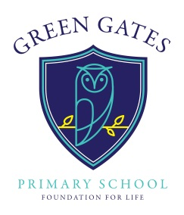

GREEN GATES PRIMARY SCHOOL
Keilder Close, Redcar, TS10 4HS
Tel: 01642 485463 Fax: 01642 483557
Headteacher: Mr D A Hodgson
email: green_gates_primary_school@redcar-cleveland.gov.uk

Autumn Newsletter 10

17th November 2017
Dear Parents/Carers
Reading
This week’s picture to discuss. Remember, when children bring back their ideas into school they will be rewarded with smilies.
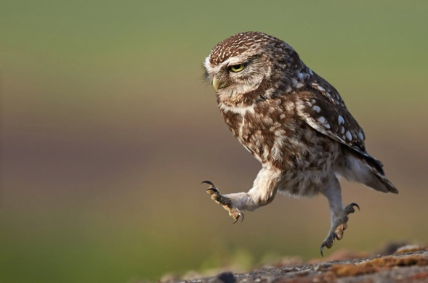
What is it that the owl has seen?
Why do you think owls are such effective predators?
Why do you think the owl is running?
What do you think it would feel like to fly?

Attendance
Attendance in school for Week 9 as follows:
Mrs Fellows’ class 96.7% 0 lates
Mrs Stone’s class 99.2% 1 late
Miss Breckon’s class were the best
attending class last week: 100%
Mrs Fellows’ children were the
most punctual.
Well done to them!
Miss Roberts’ class 98.9% 9 lates
Miss Sherwood’s class 99.3% 5 lates
Miss Breckon’s class 100% 1 late
Miss Booth’s class 98.6% 4 lates
Miss Parker’s class 98.7% 1 late
Miss Tierney’s class 98.6% 2 lates
Mrs Lowe’s class 98.4% 4 lates
Professional Development day
Just a reminder that school will be closed next week: Friday 24th November. This is a staff development day.

Writers of the Week
Our ‘Writers of the Week’ were presented with a certificate in our celebration assembly last week and their writing displayed in the hall for everyone to see. Children are chosen by their class teacher for impressive writing over that particular week. Well done to:
Mrs Fellows’ Writer of the Week was Rosie Christian
Mrs Stone’s Writer of the Week was Sophia Petch
BELIEVE

SUCCEED

ACHIEVE
Miss Roberts’ Writer of the Week was Faye George
Miss Breckon’s Writer of the Week was Ryan Yarker
Miss Sherwood’s Writer of the Week was Ashlee Bytheway
Miss Parker’s Writer of the Week was Tyler Kent
Miss Tierney’s Writer of the Week was Eva Thompson
Mrs Lowe’s Writer of the Week was Ruby Campbell
Anti-Bullying Week
We have had lots going on in school this week (see our twitter feed for more information). The children have been learning more about bullying and what to do in the event of a child being bullied. Some of the things they have said and learnt are as follows:
“Words can’t bring you down and you are beautiful no matter what anybody else says” Ella, Year 6
“We have to look after each other” Sophia, Year 1
“It doesn’t matter how you look, you’re still a person with feelings” Calvin, Year 2
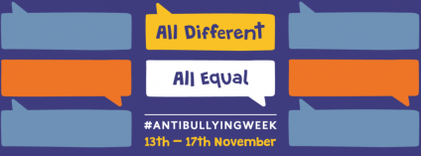
“I learnt how to help friends when they are sad” Alfie, Year 5
“Always pass a smile on and think before you speak” Danielle, Year 3
“Anyone and everyone can be bullied for any reason at all because everybody is different but that’s actually a good thing” Jasmine,Year4
“It is important to speak out if you are being bullied” Tyler, Year 5
Read for the Stars
Hot on the heels of Leo Whittleston in Year 6, these super readers have now reached the sun too! Lexie Thurlbeck, Jasmyne Walker, Kacey Leigh Brunton, Tobi Jeffels and Taliah Taylor They were presented with a certificate and a book in assembly today: well done to them! Reading everyday is part of our home school agreement and home learning. Please read with your child or encourage them to read aloud to you or to find a quiet place and lose themselves in a really good book.
Thank you for your continued support.
Mr Hodgson

