
Green Gates Primary School

Safeguarding Team
Here at Green Gates Primary School, we are committed to the safeguarding of all pupils and staff. If you have any concerns about the safety or welfare of a child or family, please contact one of us, either in person or on 01642 485463

Mrs K Lowe
Designated Safeguarding Lead
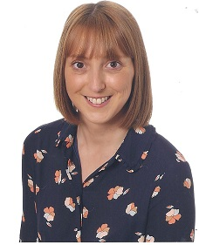
Mrs M Ovens
Designated Safeguarding Governor
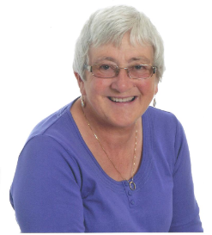
Mrs M Dowson
Deputy Designated Safeguarding Lead


